THE REPUBLIC OF UGANDA
IN THE HIGH COURT OF UGANDA AT KAMPALA
CRIMINAL snsS10N CASE NO: 0160F 2023
UGANDAPROSECUTOR

VERSUS
- MUHUMZA RICHARD
- ZANYA APOLLOACCUSED

BEFORE: HON.JUSTICE ALEX MACKAY AJIJI
JUDGEMENT
I shall baptize this judgement as "the shrinking forest ..., "
Muhumuza Richard and Zanya Apollo are jointly charged with the offence of murder contrary to Section 188 and 189 of the Penal Code Act. The Particulars of the offence are that, the two accused persons on the 15th day of May 2021 at Munyonyo, Makindye Division in Kampala District with malice aforethought caused the death of Ainebyoona Isaac. 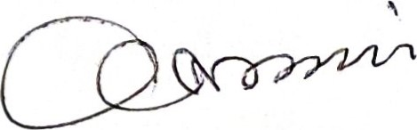
The events leading to this according to the prosecution is that,on the 14th / 3/2021 the complainant one John Kasimoni,the father of both Isaac Ainebyona and Muhumza Richard went together with his wife Kyomuhendo Rossette to Auto spa in munyonyo for a sauna. While there he called his son Isaac Ainebyona to go and find them there for the purpose of him driving them back home at night. He and his wife came out of the sauna and found Isaac Ainebeyona and Al Muhumza Richard outside and each of them were on phone.
The presence of Al at Autospa seemed to have puzzled PW 1 as to why he had gone there .According to PW 1 and Pw8 they went to the gardens of Autospa and made their orders for beers . According to PW 1 and PW8 , Al did not order for anything but stirred a drink for the deceased and which he gave him to drink while for him he just moved around. That when he brought the drink for the
deceased , PW 1 asked the accused Al to take the drink as well but Al refused saying he had ordered for milk.Eventually Al did not take anything at all.After four days , the deceased started feeling unwell and complained of stomach Ache.He developed dry lips that vvcrc darkcning and he was taking too much water.Pw1 said he was uncomfortable because he Al had given the deceased something to drink which he saw him stirring in thc glass and that he wanted to tell the deceased not to take the drink but before he could say anything Isaac had already taken the drink.
The deceased continued feeling unwell until on the 8th of May 2021 , he was taken to Nsambya Hospital for treatment and ended up in ICU .The accused kept on visiting the deceased secretly without the complainant's knowledge and his movements were suspicious. The deceased made a dying declaration to the father in the presence of his brother PW4 Mwebaze Martin that Al had killed him. Indeed, on the 15th day of May 2021 Isaac Ainebyona passed away from Nsambya hospital. The hospital stated the cause of death as covid 19 but before he died, PW 1 not believing the cause of death as stated by the hospital, requested them to provide a sample of blood of the deceased, which they took to the Uganda viral institute surprisingly the virus inscitute returned a negative result for covid and much as the deceased had been buried without a postmortem report , PW 1 went and lodged his complaint at police and the police surgeon ordered for the exhumation of his body for tests. The tests revealed that the stomach contents contained carbofuran which is an agriculture pesticides which the toxicologist describes as a dangerous, poisonous substance capable of killing as per the GAL
Report dated 12/4/2022. 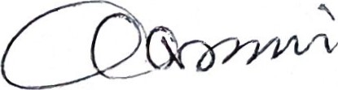
The Burden of proof
The burden of proof is always on the prosecution. The prosecution has the duty to provc cach of thc ingredients of the offence and generally this burden never shifts onto the accused, except where there is a specific statutory provision to the contrary. (see Woolmington vs D.P.P. [19351 A.C. 462, and Okethi Okale
& Ors.
vs Republic [19651 E.A. 555). This is not one of those cases where the burden of proof shifts to the accused to prove his innocence.
The standard of Proof
The standard of proof is proof beyond reasonable doubt.
All the essential ingredients of the offence are to be proved beyond reasonable doubt. This standard does not mean proof beyond a shadow of doubt. The standard is achieved if having considered all the evidence, there is no possibility that the accused is innocent. In Miller vs Minister of Pensions [19471 2 All E.R. 372 at page 373 to page 374,Lord Denning stated that:—
"The degree of beyond reasonable doubt is well settled. It need not reach certainty, but it must carry a high degree of probability. Proof beyond reasonable doubt does not mean proof beyond the shadow of a doubt. The law would fail to protect the community if it admitted fanciful possibilities to deflect the course of justice. If evidence is so strong against a man as to leave only a remote possibility in his favour,which can be dismissed with a sentence: 'of course it is possible but not in the least probable', the case is proved beyond reasonable doubt; but nothing short of that will suffice." 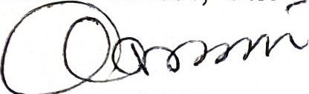
Evidence is evaluated as a whole. The Court considers evidence o both the prosecution and the defence relating to each of the ingredients before coming to a conclusion. The Court should not consider the prosecution evidence in isolation of the evidence presented on behalf of the accused. In Abdu Ngobi vs Uganda, S.C.Cr. Appeal No. 10 of 1991, the Supreme Court expressed itself as follows, with regard to treatment of evidence.
Evidence of the prosecution should be examined and weighed against the evidence of the defence so that a final decision is not taken until all the evidence has been considered. The proper approach is to consider the strength and weaknesses of each side, weigh the evidence as a whole, apply the burden ofproof as always resting upon the prosecution, and decide whether the defence has raised a reasonable doubt. If the defence has successfully done so, the accused must be acquitted; but if the defence has not raised a doubt that
the prosecution case is true. and accurate, then the witnesses can be found to have correctly identified the appellant as the person who W'cZS at the scene of the incidents as charged."
The Evidence in This Case
At the preliminary hearing prior to the trial, the following evidence was agreed to by both parties and duly admitted on the court record as such: P.EXH 1 (PF 48(C post mortem report,P.EXH 2 Addendum dated 24/10/2022,P.EXH 3 Police Form 17A,P.EXH 4 Analytical/ toxicological Analysis report,P.EXH 5 WhatsApp messages,P.EXh 6 call Data Analysis, P.EXH 7 WRI Testing Certificate, P.EXH No.8 Pictures of Al when he trespassed onto the deceased's land ,PEXH No.9 Police statement Al,PID 1 Government Analyst Laboratory, ID 2 Court Order from Makindye , PID 3 Report from the Uganda Virus Institute Covid results , PID 4 Death Summary from Nsambya,PID 5 Letter / request for access to upper prison, ID 6 Permission to access prisons . PID 7 Photocopies of warrant cards of police officers, PID 8 Prisoners Road pass
The prosecution called 11 witnesses while the Defence called 4 witnesses. The said documents were admitted on the court record as exhibits respectively.
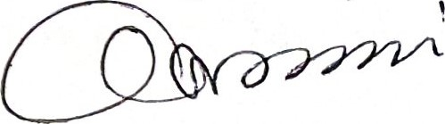

Representation
The Prosecution was represented by Ms.Nakimbugwe Irene and Wanamama Mic Isiah from the Office of the Director of Public while the accused were represented by Counsel Akanyijuka Denis, Tuhweire Richard and Twesigye Amon, Nahebwa Precious represented the accused one (Al),Counsel Kumbuga Richard represented accused two (A2) on state brief.
Both counsel made written submissions as requested by this Honorable court which I have taken note of.
On a charge of murder, the Prosecution has to prove the following essential
Ingredients as stated in the case of Uganda v Sseruwagi and 6 Others (Criminal Case 183 of 2019 as follows;

Ingredients of the offence
- Death of a human being occurrcd
- The death was caused by some unlawful act
- That thc unlawful act was actuated by malice aforethought 4) That it was the accused who caused the unlawful death

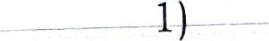Death of a Ainebyona Isaac occurred
Death, may be proved by a production of a post mortem report or evidence of a witness that saw the dead body.
It was the evidence PW 1 Mr. John Kasimoni, father of the decease that his son Isaac Ainebyona died on the 15th May 2021, that on the 7th day as it was approaching 1:00AM he received a phone call that his son had passed away. His evidence was collaborated by PW4 Mwebaze Martin a brother of the deceased and PW8 Rosette Kyomuhendo a mother of the deceased who all confirmed that indeed Ainebyona Isaac died was buried on the 17th of May 2021.The defence does not dispute this. I therefore find that the prosecution has proved beyond reasonable doubt that Ainebyona Isaac is dead.

2) The death was caused by some unlawful act
The legal position on the legality of death (or lack thereof) is that every homicide is presumed to be unlawful unless circumstances make it excusable. This position was laid down in the case of R. Vs. Gusambiza s/o Wesonga 1948 15 BACA 65. The same position was restated in Akol Patrick & Others vs Uganda (2006) HCB (vol. 1) 6, (Court of Appeal) where it was held:
"In homicide cases death is always presumed unlawfully caused unless it was accidentally caused in circumstances which make it excusable."
In Uganda vs. Aggrey Kiyingi & Others Crim. Session. Case No. 30 of 2006 excusable circumstances were expounded on to include justifiable circumstances like self defence or when authorized by law.
The term 'homicide' has been invariably defined as the killing of a human being by another human being. Therefore, in the present case the defences of the accused persons notwithstanding, the present murder indictment would prima facie place the deceased's death within the category of deaths defined as homicides. It therefore follows that the deceased's death would have been prima facie unlawful unless the circumstances surrounding the said death are such as would make it excusable or justifiable.
In this case there was no postmortem report done, however looking at the evidence of Nsambya Hospital, death was assumed to have been caused by Covid 19 and the certificate of death was showing multiple organ dysfunction syndrome, underlying condition being acute pancreatitis, diabetes mellitus positive sars covid antigen as authored and signed by Dr. Mbabazi Esther as per PIDExh 4. 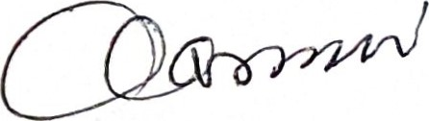
PW 1 requested for blood samples to be taken to Entebbe in a government Laboratory a day before he died and when results were returned from Entebbe, they showed that he had no covid. This is confirmed by PW9 Dr.Julian Lutwama (PHD) that indeed the results from Entebbe National Virus research Institute, herein after referred to as NVSI were received that indicated that the deceased was tested for Covid 19 and the results were negative as per PID Exh 3.
PW2 ,Ambayo Richard a superintendent of police/ a police surgeon testified that he received instructions to carry out an exhumation of the deceased and picked samples for analysis as per the court Order P.EXh form 17 as PID 1 EXH AND PID EXH2. That the exhumation was conducted, and the samples recovered were. sent to the Government Analytical laboratory for examination. However it was established that samples qualitatively contained a chemical ,carbofuran which is used in agriculture to kill pests, the possible source of this chemical could be from food/ fluid and crops when they either intentionally or accidentally ingested or exposed on skin by inhalation. And the chemical could cause acute death by affecting the quality of blood among others. And it was their conclusion and observation that the cause of death was carbofuran.
This is further corroborated by PW5 Wakabi Musa Kasode, a principal government analyst from the Directorate of Government Analytical Laboratory who confirms the same that he received samples picked from Isaac Ainebyoona for examination and his analysis established that the samples contained
carbofuran, a pesticide and toxin that was classified as highly hazardous by World Health Organization. 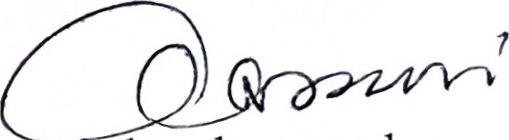
The fact of the existence of this toxic substance in the body o the deceased coupled with the symptoms that were exhibited by the deceased before he died as narrated by the father to the deceased prosecution proved that the deceased died by poisoning which is unnatural and therefore unlawful An evaluation of the prevailing circumstances of the present death is instructive. In the instant case, however, there were no circumstances presented to this court that would make the deceased's death either excusable or justifiable. Having evaluated all the evidence, I find that PW 1 , PW2 ,pw4 ,pw6and PW9 ,I find that Ainebyona's death was not natural, was not suicidal or accidental but a homicide. Not having found any lawful justification for his poisoning.
I find that the prosecution has proved this ingredient beyond reasonable doubt.

3). That the unlawful act was done with malice aforethought
Section 191 of the Penal Code Act defines malice aforethought as an intention to cause death of a person or knowledge that the act that resulted in death would probably cause the death of someone.
To prove the mens rea of murder in the present case, the Prosecution sought to rely upon the direct evidence of PW5, Wakabi Musa Kasomi as well as the documentary evidence contained in Exhibits 1 and 4 (post mortem report and toxicological analysis report).
Malice aforethought is a mental element that is difficult to prove by direct evidence. Courts usually consider circumstantial evidencc.
The evidence adduced by prosecution is that the deceased was poisoned as demonstrated in the previous ingredient.Any person who poisons another clearly has the knowledge that the act will cause harm or probably cause the death of the victim.
In the case of Uganda vs Muwonge George HC. CR. SC. NO 513/09, Justice Mwondha in her judgment cited the case of Uganda v. Kato and three others[19761 HCB 204, Hon Ag Justice Sekandi as he then was held among others that, "it's the duty of the court as far as possible to examine all the surrounding circumstances of the case including the actions of the accused, the conduct which precedes and very often the conduct which follows the killing in particular the way the killing was carried out, the nature, the number or of injuries, the nature and the kind of weapons that was used and then ask itself whether it is satisfied that at that time of the killing there must have been an intention to kill. If the court is satisfied that the intention exists then the accused must be convicted of murder." 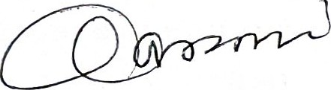
PW 4 Mwebaze testified that after the death of his brother, he approached one Dr.Mbabazi to find out what exactly had killed Isaac and she replied he died of acute pancreatitis secondary to covid . That the kidneys had started functioning well but the lungs failed him due to acute pancreatitis , this meant the pancreas had inflamed and the possible cause may be a bite from a scorpion or an organ phosphate likc a toxin.This surpriscd him and hc did not believe it.
In the instant case, The evidence of PW5(Musa Kasole Wakali) a principal Government Analyst at the Directorate of Government Analytical Laboratory the GAL analyst confirmed that the poisonous substance was seen from the toxicological analysis on P.E 4 (Analytical Report ) in the Exhibit A contents which was the stomach and Exhibit E which was part of the liver and in the liver alone it was qualitatively found to contain Carbofuran during the analysis. When asked how long the chemical may take to kill, he stated depending on the age health status and someone is managed under medical care , il. rnay lake 2-3 weeks existence of carbofuran a toxin and the toxicologist confirmed that carbofuran is dangerous toxin capablc of causing death.
To corroborate this PW 1 and PW8 testified that on 14thMarch 2021, Al bought a drink for A2 and they saw him stirring the drink that he gave to the deceased at Auto Spa in Munyonyo. That the deceased started falling sick a after four days after taking the said drink. 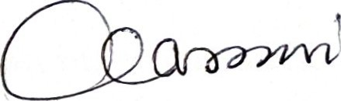
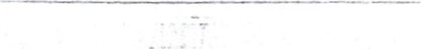
Courts usually consider the weapon used (in this case a poisonous substance) and the manner they were applied (administered to food items about to be eaten) and the part of the body of the victim that was targeted (ingested into the stomach). The impact (multiple internal organ failure). Neither accused offered any evidence on this element. Any perpetrator who administers a poisonous substance in food items about to be served, with knowledge that the food will be eaten by a human being, must have foreseen that death would be a natural consequence of his or her act. The accused did not adduce any evidence capable of casting doubt on this conclusion and neither did Defence Counsel contest this element in her final submissions. On basis of the circumstantial evidence, I find, in agreement with the assessors that malice aforethought can be inferred. The prosecution has consequently proved beyond reasonable doubt that Ainebyona Isaac 's death was caused with malice aforethought.
4) That it was the accused who caused the unlawful death
I now comc to onc pcrtincnt question which is whether or not the 2 accused persons or one of them was responsible for the. death of the deceased.
DWI Muhumza Richard denied having killed his brother. He denied all the allegations put by the prosecution that he had poisoned his brother. HC tcstified that on the 14 day of March 2021, he met with his fathcr PW 1 and his step mum pw8 and the deceased at Auto spa Munyonyo where they sat at round upto around 8:00 PM. That they ordered for drinks, that is two tuskers for PW 1 and 2 tuskers for PW8 and 2 glasses of juice. The drinks were brought by the waiter and were placed on a table near where they were seated. DWI then stood up and served each of them but served his young brother the deceased last.
During cross examination he testified that pwl ordered for beers for himself and his wife PW8 . Then for him he walked with his brother to the serving area and the deceased ordered for a cocktail drink which was made by the barmaid whom they found at the serving area and he handed over the cocktail to the deceased.
He further denies the allegation that while in jail he sent one Rwamucwo to finish up his father PW 1 ,PW8 and the investigating officer.
DW2 Zanya Apollo
He denied having been an accomplice to the murder of Ainebyona Isaac. He also denied having had an airtel number 0759976482 and MTN 0783755432.He further testified he was hit on the head to sign the papers. He also denied knowing Jackson Kibuuto and did not have any connection with it.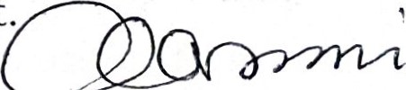
The evidence against the two accused persons is basically circumstantial. The law is that where prosecution case depends entirely on circumstantial evidence such circumstantial evidence must be of such a nature that it does not point to anything else other than the guilt of an accused person; Simon Musoke v R. (1958) EA 715. It is also the law that before the court can base a conviction on such evidence it must be satisfied that there are no coexisting factors tending to weaken or detour the circumstantial evidence: Teper v R (1952) AC at page 489 and Israili Epuka s/ o Achietu v R (1934) 1 EACA 166 at page 168. In the present case it is the circumstantial evidence upon which prosecution based its case to connect Al to the act.
To refute the defence evidence, I will base on the purported dying declaration.
valuable circumstantial evidence and identification evidence.

a) Dying declaration made by the dcccased before PW1 Kasamoni
Section 30 of The Evidence Act defines it as a statement made by a person who believes he is about to die in reference to the manner in which hc or she sustained the injuries of which he or she is dying, or other immediate cause of his or her death, and in reference to the person who inflicted such injuries or the connection with such injuries of a person who is charged or suspected of having caused them. Dying declarations however, must always be received with caution, because the test of cross examination may be wanting and particulars of violence may have occurred in circumstances of confusion and surprise. Although corroboration of such statements is not necessary as a matter of law, judicial practice requires that corroboration must always be sought for.


In the instant case, PW 1 Mr. John Kasimoni, testified that While at the hospital the deceased became worse that night and he started telling the people around him to call his father who was PW 1. When PW 1 came, the deceased was put on a wheel chair and when he reached his father, he put his head on his father and told him, "daddy Richard has finished me." 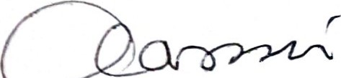
I wish to note however that evidence of a dying declaration per se cannot form a basis for a conviction unless it is satisfactorily corroborated with other independent evidence this was cited in the case of In Uganda vs Benedict Kibwami (1972) ULR 28 as cited in Uganda Vs Innocent Kyarigaba CRIMINAL SESSION CASE NO. 0007 OF 2015; it was held that it was not a rule of law that in order to support a conviction, there had to be corroboration of a dying declaration and there might bc circumstances which show that the deceased could not have been mistakcn in his identification of the accused. But it was generally speaking very unsafc to base a conviction solely on a dying declaration of a dcccased person madc in the absence of the accused and not subject to crostg, czarnination unless there was satisfactory corroboration. I shall therefore caution myself, like I cautioned the Assessors during the briefing.
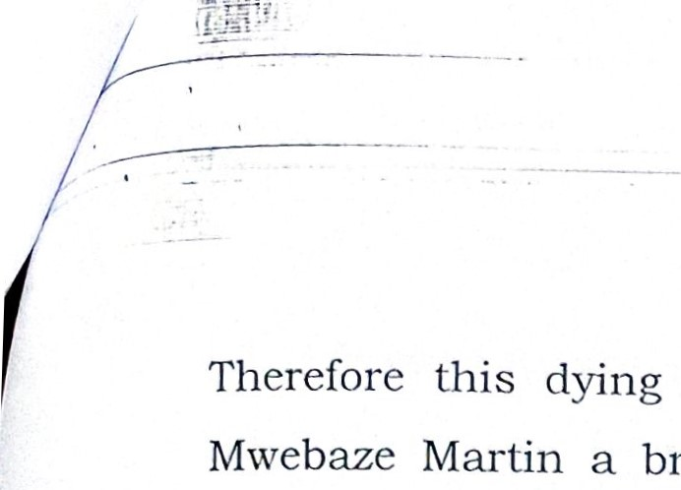
Therefore this dying declaration made to PW 1 was corroborated by PW 4 Mwebaze Martin a brother to the deceased who testified the deceased kept wailing and told his father "I know who has done this and he yelled further that Richard has killed me."
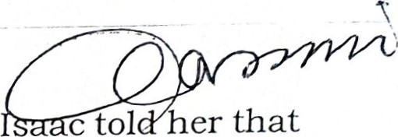
Further PW3 , Doreen a girl friend to the late, testified that she was very close to the Isaac that he would tell her everything. That he was scared for his life since his father wanted him to be his heir but his brother Muhurnza wanted it all and that he was getting threats every day and this made him scared of his life. That he was being targeted because of the property of his father.
tol
er
that
c
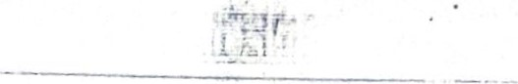
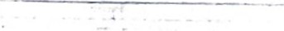
PW8 Kyomuhendo Rosette testified that one year to his death, he felt things were heavy on him, that he may not make it to 30 years on earth from the words Al kept sending to him, he felt he was very scared. That Al said he wanted heirship. I have found that that the testimonies of PW 1 ,PW4 and PW8 on the dying declaration pinning the accused person are reliable.Hence the deceased's dying declaration implicated the accused.
b) CIRCUMSTANCIAL EVIDENCE.

i. Subsequent Conduct
PW4 Mwebaze testified that during the burial on 19/ May / 2021, when PW 1, Mr. John Kasimoni, the father to the deceased announced that Al had poisoned his brother, Al 's behavior changed and it was not normal. He fled from the burial. He then went and sent a message in form a proverb in June 202 Ion their WhatsApp group called Kasimoni Foundation group saying " a forest is shrinking ,but the trees kept voting for the axe for the axe was clever and convinced the tress but because his handle was made of wood he was one of them."Furthcr corroboratcd by PW6 Assimwe Abel who tcstificd that Al added that I know there are some dying to slap me but I am just in your phone ... wait until we meet in person and added pictures of smiling graphic emojis. Marked WhatsApp message "PID 5".
The family interpreted this,"as you cannot know what is finishing you because its among you." However, this behavior continued . PW 1 tried to hold meeting, however whenever the meeting was held, he would not show up without reasons and communication. 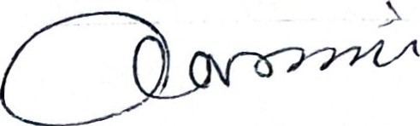
In Uganda Versus Yowana Baptist Kabandize (1982) I-ICB 93, this Court held that the conduct of the accused immediately after the death of the deceased of running away from the scene of crime and of being in a restless mood in the swamp clearly showed a guilty mind and in Remegious Kiwanuka Versus
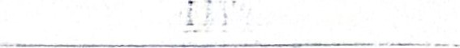
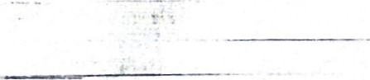
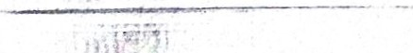
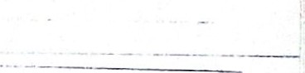
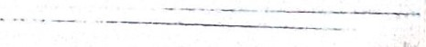
Uganda Criminal Appeal 41 of 1995, the Supreme Court held that the disappearance of an accused person from the area of a crime soon after the incident may provide corroboration to other evidence that he has committed the offence. This is because such sudden disappearance from the area is incompatible with innocent conduct of such a person. When I analyze the conduct of the accused during the burial and he disappeared after the burial and he sending an insensitive riddle to the family group named Kasimoni Foundation as per PID 5. I find that no one challenged the existence of Kasimoni Foundation .1 therefore find that this is very clear to any one from the perspective on what it meant regarding to the death of the deceased, I find his conduct incompatible with innocence.
ii. Threats .
Evidence of a threat was considered by the Court of Appeal for East Africa in the case of Waihi and Anor Vs Uganda(1968) D.A. 278. Spry J held at page 280 thus:
Evidence of a prior threat or of an announced intention to kill is always admissible evidence against a person accused of Murder, but its probative value varies greatly and may be very small or even amount to nothing. Regard must be had to the manner in which a threat is uttered, whether it is spoken bitterly or impulsively in sudden anger or jokingly, and the reason for the threat, if given and the length of time between the threat and the killing are also material. Being admissible and being evidcncc tcnding to connect thc accused person with the offence charged, a prior threat is we think capable of corroborating a confession
During Cross examination of PW4 Mwebaze, testified that accused deviated from the usual norm of his behavior and sent derogatory statements on the family group captioned "that I know that there is nothing you can do to me and you wait until we meet in person.
Also on the 8th August 2022,one Rwaamucu Joseph came with a paper from Luzira showing that he had been released on 8th and he did not rest, he decided to look for pw8 (Kyomuhendo Rossete) from Kikuubo and got pwl 's number,he later was told to go to kabalagala police OC CID 's office and he told him how knew his whole family and told him he ought to be careful " your brother wants you ,your dad and your mother dead. PW 1 collaborated this evidence when he testified that he received a call from a gentleman, latter who came to be known as Rwamokyo claiming to want to purchase his property but his conduct was suspicious. 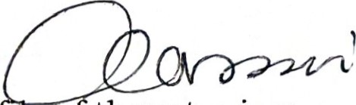
Also PW 10 Turyasingura Patrick testified that he investigated a 1 e o threatening violence reported by PW 1 against a one Rwamukyo Joseph.That he interrogated the said Rwamukyo Joseph and his investigations established that Rwamukyo was previously an inmate at Luzira together with Al.
PW3 Nayesiga Doreen a girl to the late Isaac Ainebyoona ctestified that om the 14th ofJune 2020 while at Freedom city having something to eat to whether with the deceased , a strange number called him 075 9976482 and the voice was for amale telling him that he had been paid to poison the deceased's they put the phone on loud speaker and decided to call him again , the person him to meet him in either Rakai or Mubende .After the death of Isaac , thc numbcr was traccd to one Zanya Apollo A2 in this case.
This is corroborated by the testimony of PW7 Detective AIP Magoola Brian attached to CID headquarters department of crime Data Management. Who made analysis of the data prints outs of 07529976482,0704621244 and 0758084479 vide Kabalagala GEF06/2021 and his findings were that 0704621244 was of Richard Muhumza Al and 0758084479 belonged to Ainebyona Isaac.
However, 07529976482 belonged to one Jackson Kibutto who communicated to Isaac on the 14th June 202 at 11:12:23 hrs and was followed by Isaac calling back at 15:37:07 hrs and then followed by messages from Kibuto to Isaac on the 15th June 2020. When the person was arrested who was using the number, it was realized that the person arrested who was using the number in the names
of Kibuto was not Kibuto though the number was registered in the names of Kibuto from the service providers.
Regarding the evidence of threats made to both the deceased and the family by both Al and A2. 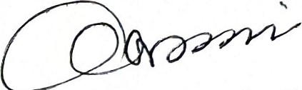
I will first discuss Al, the evidence regarding Rwarnucu an ex —convict who had been allegedly been sent by Al to finish up the remaining family that is PW 1,
PW8 and PW4.This conduct by Al shows the motive and intention to ensure that all the living witnesses to the alleged murder of Ainebyona are dealt with so as to ensure that this matter is closed.This conduct of sending Rwamucu to finish up pw1,pw4 and PW8 is not a conduct of an innocent person.
However in regards to the data Analysis connecting A2 to the murder, there is no sufficient evidence of direct communication between Al and A2 as to regards to phone print out.lt therefore proves that there is no connection whatsoever apart from finding the SIM card in the phone that was being used by A2.Court also has to be aware of different scenarios where someone uses another's phone to make a particular call while the user is not aware of what exactly is being discussed .Therefore regarding thc above evidence I find that the prosecution has failed to prove beyond reasonable doubt A2 conspired with Al to cause the death of Isaac Ainebyona.

iii. Grudges
PW 1 and 8 testified that Al had grudges against his brother regarding land located at Bushojwe were the accused had even encroached part of his brother's land(deceased) and he wanted to own all of it.
This is corroborated by PW 11, Lubare Geoffrey's testimony regarding the alleged cause of grudge between the deceased and Al, he discovered that the land was located in Bushojwe village Kichamba Parish Rukungiri District and on his interaction with the neighbors he noticed and LCI and conformed that indeed
Al had encroached about 69 ft on the deceased's land and built two poles made of concrete as per P.EXH 8.
This grudge explains Al 's motive and malice aforethought to end the life of Isaac Ainebyona.
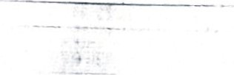


iv. Inconsistencies and contradictions. 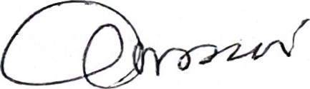
The law now governing inconsistencies or a discrepancy is that grave inconsistencies if not satisfactorily explained will usually result in the evidence of the witness being rejected. Grave inconsistency or contradiction is the one that goes to the root of the case.The more prominent contradictions and inconsistencies in the defence case include the following; -
DWI Muhumza testified while at Autospa, the four of them made orders when they came, they put them aside, he then picked them and put them on their table, he passed the four Tusker Lite for his dad then other four for to his step mother(PW8) plus the juice for my brother because my brother was close to my step mother the other side. So I passed over the juice. Further that the allegations that it is him who actually picked a glass of juice and served it on Isaac is false He further repeats during examination in chief that he was the one who served all of them. Further when asked if So it was not true that he was the one who served the deceased, he again replied that It was not true.
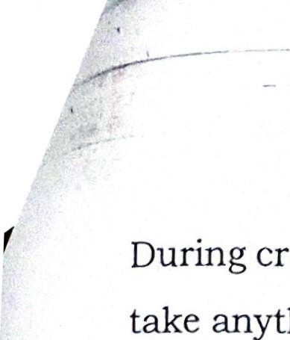
During cross examination, he was asked if the allegation that he actually did not take anything but ordered for tea was true, he replied those were all lies. All the drinks he ordered, he consumed them, He did not leave anything on the table.
Further that he ordered for tea, Mzee Kasimoni ordered for beers for himself and his wife then he moved with the deceased at the serving area and Ainebyoona ordered for a cocktail drink which was made by a barmaid whom they found at the serving area and he handed over the cock tail to Ainebyoona Isaac.
When asked if that story on paper tally with the story he had told court?
He replied that when they reached Auto Spa, they were put in the middle of others because people were many, they ordered for their drinks, when they brought the drinks they put them on the separate table, so he moved the drinks to their table and served them to his people as first was my dad, second my step mother, 3rd was Isaac.DW1 gravely contradicted himself on who served the deceased the cocktail drink , somewhere he states that he served him last after everyone had been served, then he also states that he walked to the c
I have considered the range and character of the contradic ons and inconsistencies so highlighted. I have found them to be grave in so far as they relate to matters which are central to the issues in this case. They do relate to matters which are central to the decision in this case. Therefore, the evidence suggests that the contradictions were the result of deliberate untruthfulness on the part of Al to whom they are attributed to.
c) IDENTIFICATION EVIDENCE
PW 1 John Kasimoni testified that on 14 ^{th} March 2021, Al bought a drink for the deceased and he saw him stirring the drink that he gave to the deceased at Auto Spa in Munyonyo to drink. When asked Al to taste what he had given his brother, Al refused saying he had ordered for milk hence he shall not drink the juice. That the deceased started falling sick after four days after taking the said drink.
PW8 Rosette Kyomuhendo said while at the Auto spa, as they were seated with her husband PW 1 and Ainebyona Isaac. DWI,Muhumza started moving around and he was on phone. After a while he disappeared from them but she did not know where he was. The waiters served them with drinks and Isaac was seated drinking nothing. As they sat for some time they realized Al was nowhere to be seen, PW 1 then asked where he was, they started looking for him and they saw

him in one place where they were mixing drinks. They saw him stirring something in a glass but they did not know what he was stirring. He then brought it and gave to Isaac, the deceased who took it .PW 1 told him to sit there and drink it together with the deceased but he replied and told him he was going to take milk tea since he had ulcers. After four days the deceased called him that he was not feeling well. He was feeling fire in his stomach. She gave him money and he went to the hospital where he was given some medication. PW8 Kyomuhendo Rosette, in cross examination, testified that she saw indeed saw Al string a drink with the help of the lights all over at a distance of 50 meters at around 8:30 pm. 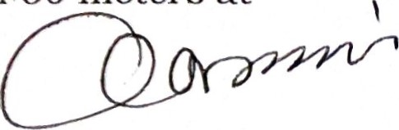
In this case, court has to determine whether or not PW 1 and PW8 Were able to recognize the accused(A1). In circumstances of this nature, the court is required to first warn itself of the likely dangers of acting on such evidence and only do so after being satisfied that correct identification was made which is free of error or mistake (see Abdalla Bin Wendo v. R (1953) 20 EACA 106; Roria v. R [1967] EA 583 and Abdalla Nabulere and two others v. Uganda [1975] HCB 77). In doing so, the court considers; whether the witness was familiar with the accused, whcthcr thcrc was light to aid visual identification, the length of time taken by the witness to observe and identify the accused and the proximity of the witnesses to the accused at the time of observing the accused.
As regards to familiarity, the witnesses both knew the accused prior to thc incidence since he was their son. In terms of proximity, P. W. 1 and PW 8 saw the accused mixing and stirring the cocktail drink for the deceased at a distance of 50 meters which was near for them to recognize him and see what he was clearly doing. In terms of light, it was during the night at around 8:30pm and her vision was not obstructed and they were aided by lights all over [he spa. As regards to duration, the identification of the accused (Al) took a reasonable period of time, that was long enough to aid correct identification.
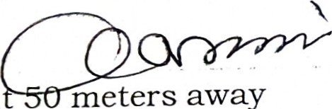
This is corroborated by the evidence pf PW 11 who testified that during his investigations, he went back to Auto spa Munyonyo and visited the scene, he found that the place pwl was seated that day was 26 meters to the serving point where they were serving cocktails. When asked about the source of the light, he testified that it was security lights.
away
meters
I know that PW8 said that when they were seated, Al was abou while PW 1 said the distance was very short this is cured by the investigating officer PW 11 who visited the scene who said that the distance was about 26 meters away. I therefore find that the accused(A1) was properly identified at Auto spa stirring the drink that was consumed by the deceased.
From the prosecution evidence I note that Alwas sufficiently placed at the scene of crime. However, much as A2 is among the accused and was alleged to have communicated to the deceased. I am inclined not to believe the prosecution's evidence since it does not seem to place A2 at the scene of crime during the commission of the offence. Therefore, there was no evidence linking Al to A2 in the commission of this offence.
T find that the state has not proved beyond reasonablc doubt that A2 participated in the murder of Ainebyona Isaac. I therefore find A2 innocent and I acquit him accordingly. He should be released from custody unless lawfully held in connection with some other offence.

Also Regarding the Defence 'submissions on the medical evidence based on the post mortem report, The defence called DW3, Dr.Joseph Jagenda to testify on behalf of other two doctors who had examined the deceased in Nsambya but ended up contradicting the evidence of the other doctors especially on the issue of covid 19 and as to why they did not apply covid protocols in ICU , at the vigil,and during the burial. He also said that it was possible for the doctors to get a diagnosis wrong and this appears to be the situation in this case. All in all, the cross-examination of the doctors left them perplexed as to the cause of death. Therefore, in agreement with the opinion of the—assessors,- I find that the prosecution has proved beyond reasonable doubt the element of the deceased having been poisoned and that Al before court is the perpetrator. 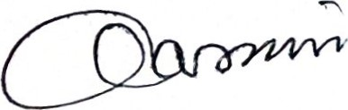
I hereby convict Al, Muhumuza Richard for the offence of Murder c/ s 188 and
189 of the Penal Code Act.
Dated at Kampala this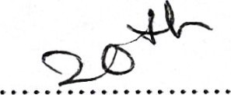day of 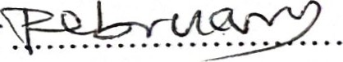. 2024
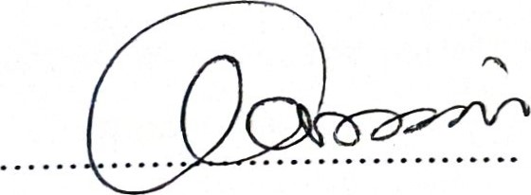
ALEX MACKAY AJIJI
JUDGE

SENTENCING
Aggravating factors:
I do not have any criminal record against the convict, but the offence is serious. This offence has a maximum sentence of death. The sentencing guidclincs provide in the schedule the range to be between 35 years to death. This case is unique and it is with the family, a brother a killing a brother. In cases of this nature prosecution shall seek a deterrent sentence with the range provided by the law.
Mitigating factors:
Dennis Akaijuka:
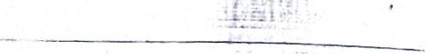
Much as the accused has been convicted. He asks for a lenient sentence.
Amon Twesigye: 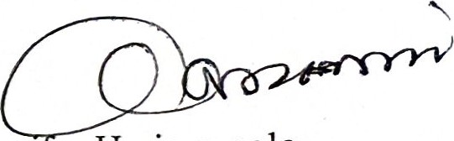
The accused is a family man with children and has a sick WI e. He is a sole bread winner, the source of their livelihood. I pray that court puts that into consideration.
Court's sentence and reasons
I have considered the aggravating and mitigating factors as well.
Though there is no criminal record cited on the accused, this kind of death has a capacity of wiping out the whole family. This should be checked throug a deterrent sentence for if not checked, children will begin taking the lives of their parents and possible competitors on account of the wealth in the family. I must say the convict has demonstrated that he is a dangerous man if left at large.
I therefore sentence the accused to 44 years' imprisonment with an order that the period of 2 years 2 months and 29 days spent on remand to be deducted so that he serves 42 years and 9 months' imprisonment.
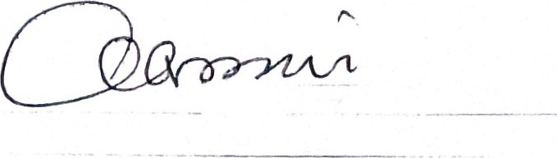
This should serve as a lesson for the accused and others as well.
Right of Appeal explained.
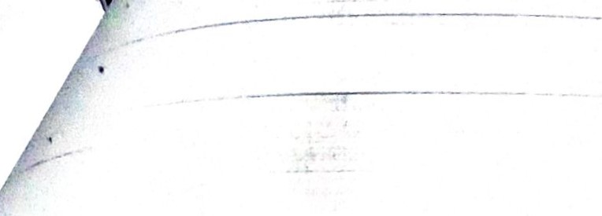
Dated 20/02/2024
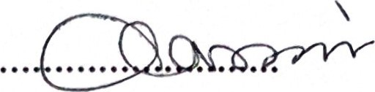
ALEX MACKAY AJIJI
JUDGE

